Average wind gust speeds hitting Tippecanoe Public Library

Karim El-Sharkawy

EAPS 227 Lab 4

21 November 2021

**Introduction:**

The intention of this report is to investigate a real email inquiry received by Professor Tanamachi. The librarian at the Tippecanoe Public Library (TCPL) wanted to know the average wind gust speeds and if the library was free from any possible severe weather damages.

The email:

“Does the Downtown Library location on South Street provide any protection from high winds and [...] possible severe weather damages. Specifically, are we more protected in the valley created by Wabash River, between the hillside of West Lafayette and the high point of Five Points intersection in Lafayette?”

There are two WHIN weather stations that are close to the TCPL. The Columbian Park station is uphill and the Pedestrian Footbridge station is downhill from the TCPL (see figure 1 below). Our null hypothesis (what we’re assuming to be true) is that winds speeds uphill from the TCPL are the same as those that are downhill from TCPL. Our alternative hypothesis (what we want to test) is that winds speeds uphill from the TCPL differ from those that are downhill from TCPL.

**Instruments:**

The instruments used in this experiment to collect wind speed data were WHIN stations (WHIN 2020). Both were commercial-off-the-shelf Davis Vantage Pro 2 weather stations. The weather stations have a wind speed resolution of 1 mph, a minimum accuracy of +/- 2 mph (this is very significant), and an update interval of 2.5 seconds (Davis p56).

**Methods:**

The WHIN weather stations are located at the Pedestrian Footbridge and Columbian Park (one at each). The pedestrian footbridge station has data before even 2021, however, the data taken is from March 26th till the 1st of November 2021 because the Columbian park station wasn’t installed and recorded until then. Therefore, data from March 26th till the present day is used. The WHIN stations collected all the needed data with their instruments. The anemometers on the WHIN stations are cup anemometers. About 21 thousand data points were collected and they were plotted on a scatter plot (figure 2). When looking at the scatterplot of the wind speeds, there were an unusual amount of zero values. This was due to a logging error where the pedestrian bridge station recorded too many zero mpg wind speeds. Therefore, these 0 mph values were removed and shown in figure 2 below. The scatter plot and image (figures 1 and 2) were coded and/or provided by Professor Tanamachi. All the WHIN station data is provided by Zach Mason.

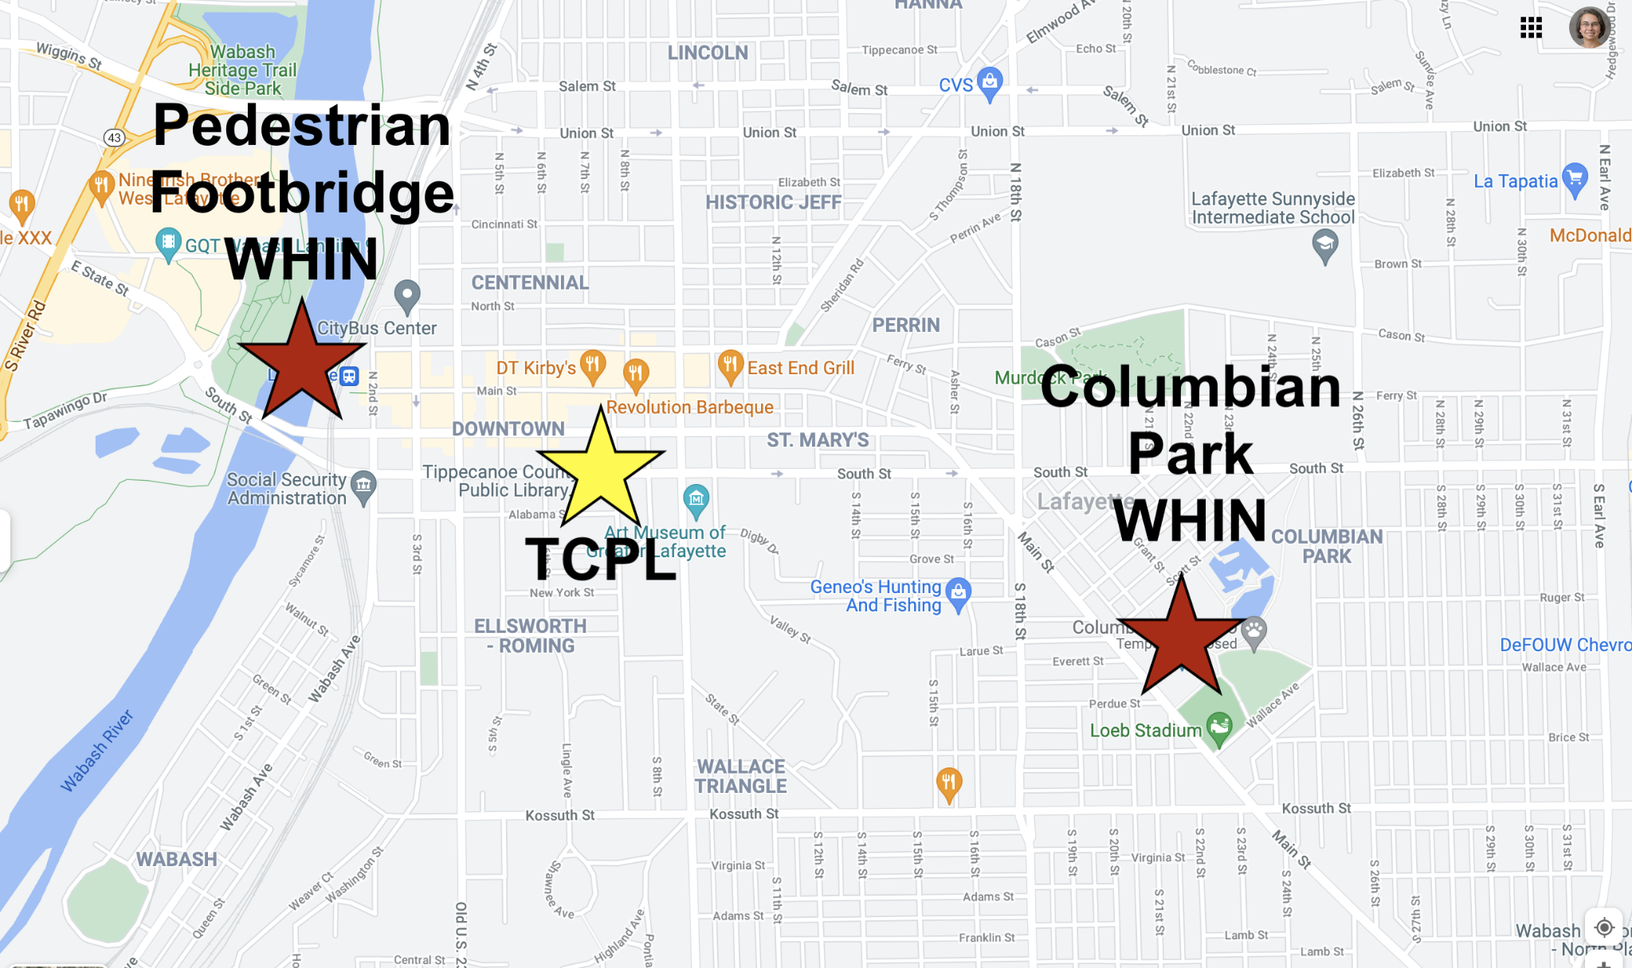

Figure 1: Map showing the alignment of the library and the two WHIN weather stations

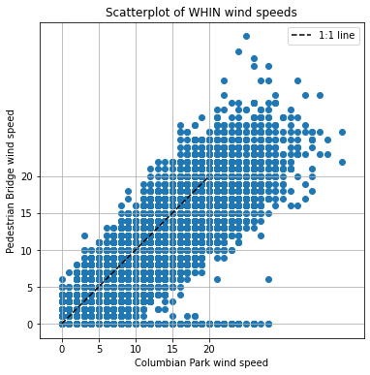

Figure 2: Scatterplot of all the collected data (wind gust speeds in mph with zeros removed)

**Data:**

Looking at figures 3 and 4, it seems that the Columbian Park WHIN station recorded higher data (wind gust speeds) than the Pedestrian Bridge WHIN station. However, it’s not a dramatic number of recorded observations, it’s only a slight difference. Table 1 shows the mean average and standard deviation of the wind gust speeds in mph. Two types of plots are shown, a histogram and a box-and-whisker plot. The Histogram and Box-and-Whisker plot were coded and provided by Professor Tanamachi. These are shown only for ease (perhaps one is easier to read than another).

Table 1: Means and standard deviations of Columbian Park and Pedestrian Bridge wind speeds (in miles per hour) after removing 0 mph gusts

| Name | Mean wind speeds (mph) | Standard Deviation |
| --- | --- | --- |
| Columbian Park | 10.4304 | 5.7870 |
| Pedestrian Bridge | 9.1243 | 5.3219 |

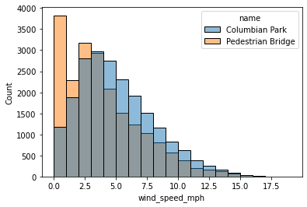

Figure 3: Histogram of wind gust speeds (in mph) for Columbian Park and Pedestrian Bridge (grey is overlap)

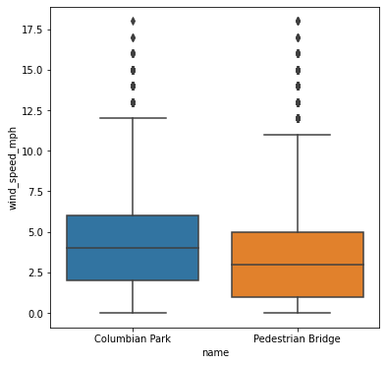

Figure 4: Box-and-Whisker plot of the wind gust data (in mph) from the two stations

**Discussion:**

Looking at table 1, it seems that the difference between the mean gust speeds has a magnitude of 1.3061 which is lower than the +/- 2 mph uncertainty given earlier. Since the difference of means is less than the accuracy/uncertainty, it can be assumed the two distributions are statistically indistinct. Based on these results, we fail to reject the null hypothesis. The null hypothesis stated that the uphill and downhill wind gust speeds from the TCPL are the same. Our alternative hypothesis stated that they were different.

**Conclusion:**

Based on our failing to reject the null hypothesis that the average wind gust speeds were different, I would say that the librarian may have to worry about the safety of the downtown library and that it is protected and safe from strong winds or severe storms. I believe that the library should get better and stronger roofing because it’s likely that the roofing they have now might not be up to par.

Email draft:

Hello,

Looking at the data of wind gust speeds, It seems that the library might need to install better roofing to deal with the wind gusts because it is not enough to protect the library against any severe weather.

Best,

Karim Muhammad El-Sharkawy

**Citations**

Davis Instruments Corp., 2021: *Vantage Pro2 Console Manual*. Y. Davis Instruments, 60 pp. [Available from: <https://cdn.shopify.com/s/files/1/0515/5992/3873/files/07395-234_im_06312.pdf>]

Wabash Heartland Innovation Network, 2020: WHIN – Weather. <https://www.whin.org/weather>.